Problem 2:

Given, P(s) = $\frac{K}{s(Ts+1)}$; C(s) = $K_{p}(1+K_{d}s^{β})$;

where K = 1.52, T = 0.4, β = 0.844, $K_{d}$ = 0.368, $K_{p}$ = 13.86

C(s) = $K_{p}(1+K_{d}s^{β})$;

= $K_{p}K_{d}(s^{β}+\frac{1}{K_{d}})$,

Now,

L(s) = P(S) C(s)

= ($\frac{K}{Ts+1})( \frac{1}{s} )$ $(K_{p})(K_{d})(s^{β}+\frac{1}{K_{d}})$

Putting the given values

L(s) = ($\frac{1.52}{0.4s^{1}+1}$) $(\frac{1}{s} )$ (13.86) (0.368) $(s^{0.844}+\frac{1}{0.368})$

= (1.52) ($\frac{1}{0.4s^{1}+1}$) ( $\frac{1}{s} )$ (13.86) (0.368) $(s^{0.844}+\frac{1}{0.368})$

Now, separating the basic terms form L(s) = ( $\frac{K}{Ts+1})( \frac{1}{s} )$ $(K_{p})(K_{d})(s^{β}+\frac{1}{K_{d}})$ the asymptotic calculation of $\frac{K}{Ts+1}, \frac{1}{s} ,$ $K_{p}, K_{d} and (s^{β}+\frac{1}{K_{d}})$ is shown below

1. For , |T(jω) | = 20log ($K_{p}$)

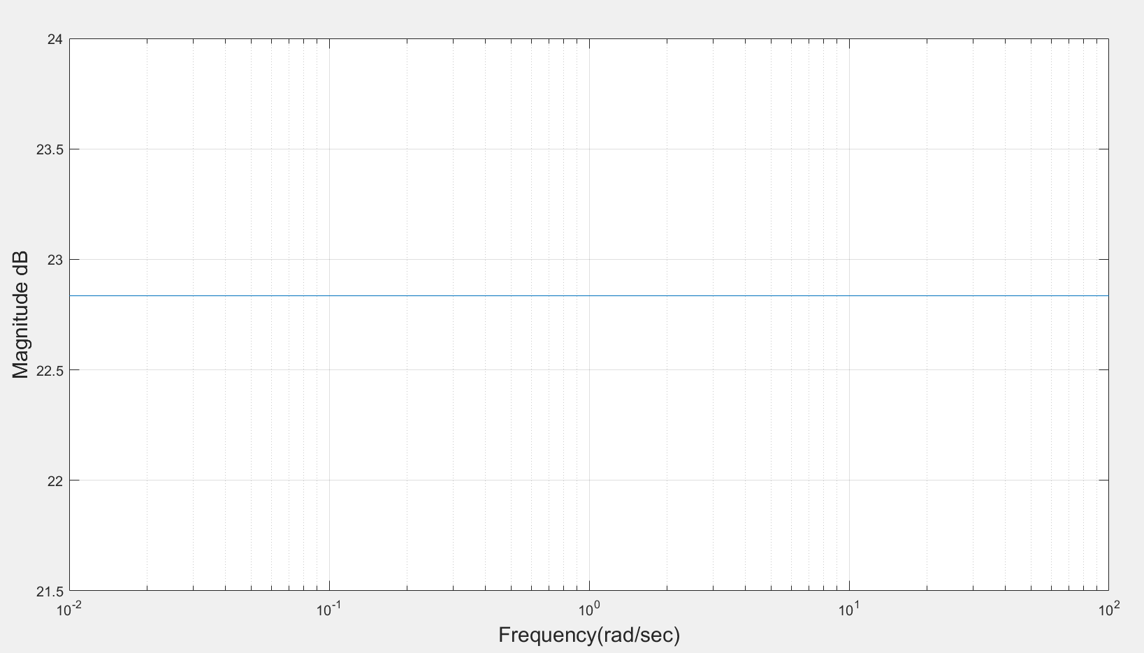

Figure 1: Asymptotic magnitude bode plot for constant gain, $K_{p}$

1. For , |T(jω)| = 20log ($K_{d}$)

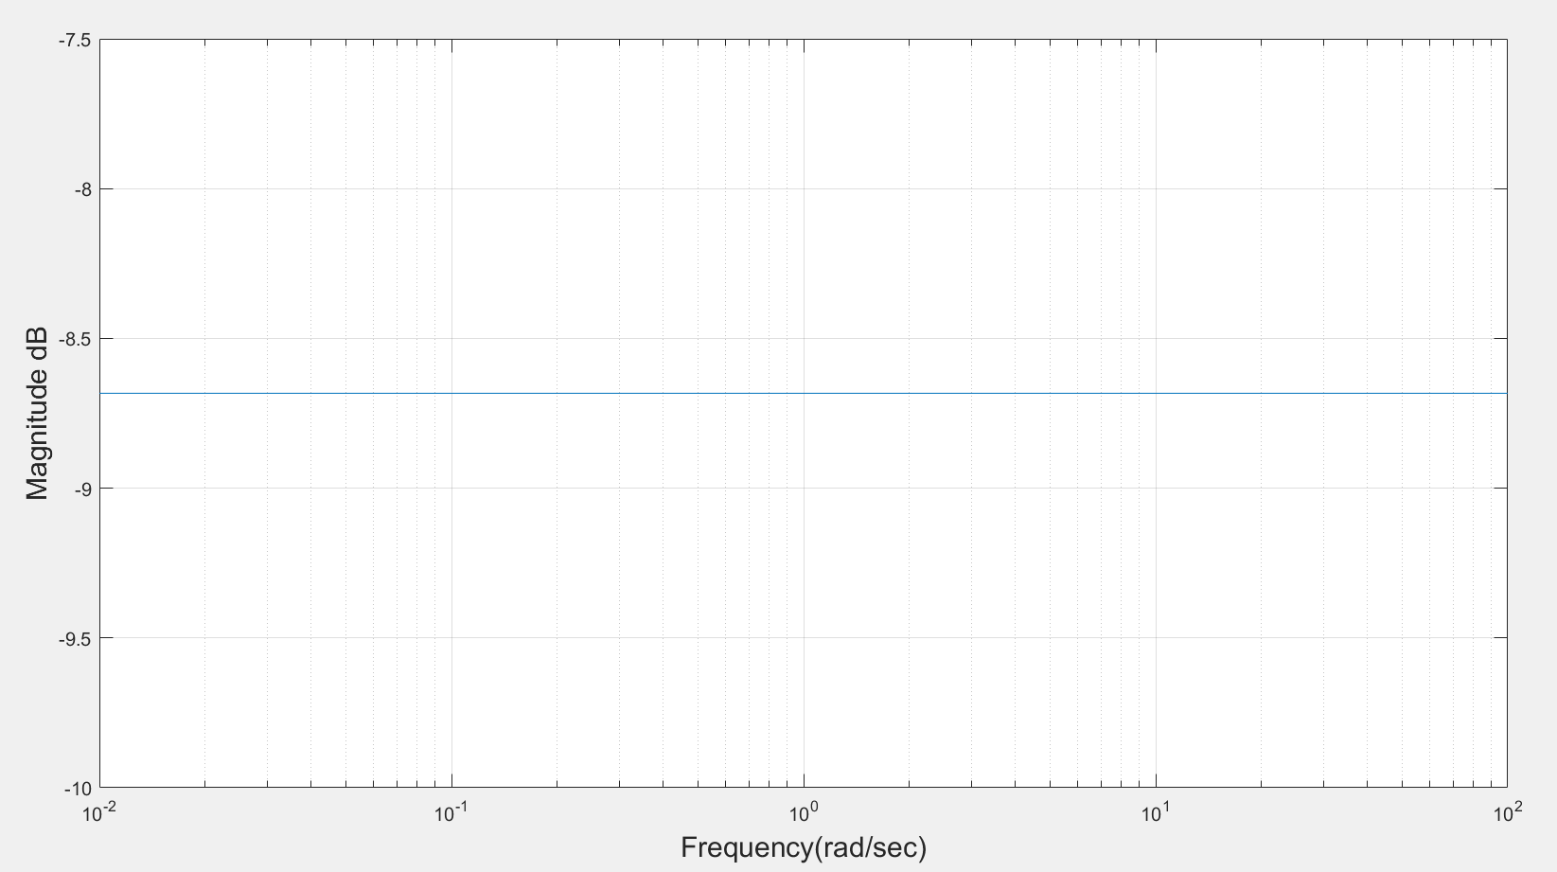

Figure 2: Asymptotic magnitude bode plot for constant gain, $K_{d}$

1. For K, |T(jω)| = 20log (K)

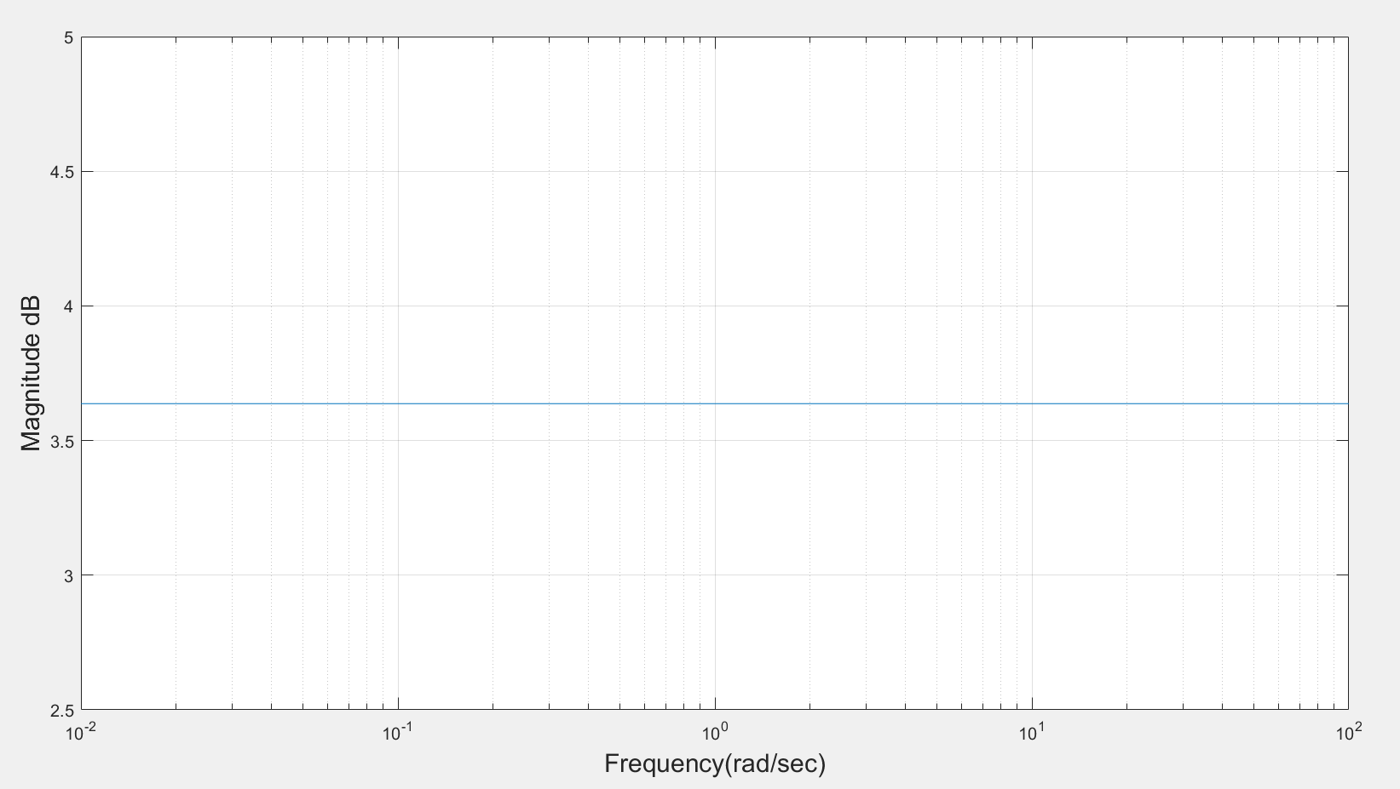

Figure 3: Asymptotic magnitude bode plot for constant gain, K

1. For, ($s^{β}+\frac{1}{K_{d}})$

Fractional zero transfer function is given by T(s)= $s^{β}+\frac{1}{K_{d}}$…... (1)

Put s = jω, in equation (1) results into T(jω) = $({jω)}^{β}+\frac{1}{K_{d}}$…… (2)

Magnitude in dB is given by |T(jω) | dB = 20log ( $\sqrt{{(\frac{1}{K_{d}})}^{2}+ω^{2β}+2{\frac{1}{K_{d}}ω}^{β}\cos{\frac{πβ}{2}}}$)

**Calculation procedure**

$({jω)}^{β}$

= $({0+1j)}^{β}$ = ${ \text{(cos}\frac{π}{2}+j\text{sin }\frac{π}{2}\text{)} }^{β}ω^{β}$

Applying De Moivre’s theorem in above equation we get

= $\text{(cos}\frac{βπ}{2}+j\text{sin }\frac{βπ}{2}\text{)} ω^{β}$…… (3)

Put equation (3) in (2) we get

T(jω) = $\text{(cos}\frac{βπ}{2}+j\text{sin }\frac{βπ}{2}\text{)}ω^{β }$ + $\frac{1}{K_{d}}$

= $\text{(}ω^{β}\text{.cos}\frac{βπ}{2}+\frac{1}{K_{d}})$ + $jω^{β}\text{sin }\frac{βπ}{2}$

Magnitude, |T(jω) | =

=

Now, Magnitude in dB, |T(jω) | dB = 20log ${\text{\{}ω^{2β}\text{+ }{(\frac{1}{K_{d}})}^{2}\text{+ }2ω^{β}\frac{1}{K_{d}}\text{cos}\frac{βπ}{2}\text{\}}}^{\frac{1}{2}}$

In the sum ${\{ω}^{2β}\text{+ }{(\frac{1}{K_{d}})}^{2}\text{+ }2ω^{β}.\frac{1}{K_{d}}\text{cos}\frac{βπ}{2}$}, $({\frac{1}{K_{d}})}^{2}$ dominates at lower frequencies whereas $ω^{2β}$ dominates at higher frequencies.

For approximation we consider ${(\frac{1}{K_{d}})}^{2}$ = $ω^{2β}|_{ω=ω_{cr}}$.We obtain corner frequency, $ω_{cr}$ = ${|\frac{1}{K_{d}}|}^{\frac{1}{β}}$

Now, following approximation of magnitude is obtained:

1. For ω ≤ , |T(jω) | dB = 20log ${\{({\frac{1}{K_{d}})}^{2}\}}^{\frac{1}{2}}$ = 20log||
2. For ω >, |T(jω) | dB = 20log ${(ω^{2β})}^{\frac{1}{2}}$ = 20βlog ω

**Procedure**

* Compute the corner frequency $ω_{cr}$ = ${|\frac{1}{K_{d}}|}^{\frac{1}{β}}$ and locate the point at magnitude 20log||.
* Draw a slope 0 dB/decade for ω ≤ $ω_{cr}$ and a line with slope 20β dB/decade for ω> $ω_{cr}.$

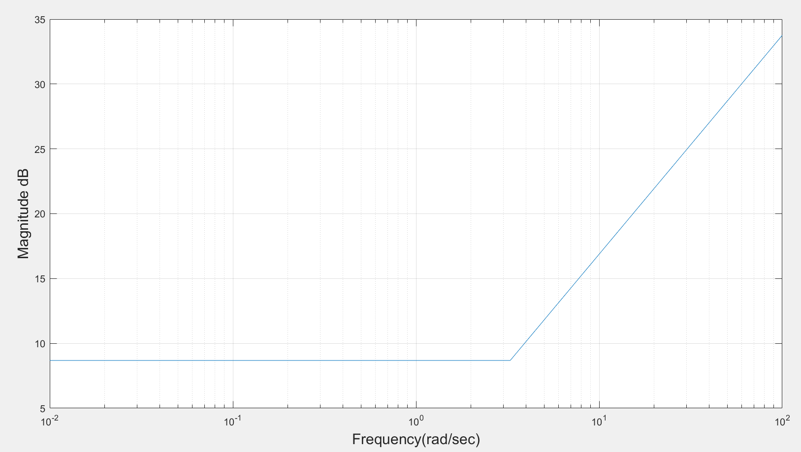

Figure 4: Asymptotic magnitude bode plot for ($s^{β}+\frac{1}{K_{d}})$

1. For, $\frac{1}{s}$

Fractional zero transfer function is given by T(s) = $\frac{1}{s}…$…… (1)

Put s = jω, in equation (1) results into T(jω) = $\frac{1}{jω}$……. (2)

Magnitude in dB is given by |T(jω)| dB= -20logω

**Calculation procedure**

$(jω)$ = $\left(0+1j\right)$ = $\left(\text{cos}\frac{π}{2}+j\text{sin }\frac{π}{2}\right)ω$

Put equation (3) in (2) we get

T(jω) = $\frac{1}{\left(ωcos\frac{π}{2} +jωsin \frac{π}{2} \right) }$

Magnitude, |T(jω) | = = =

Magnitude in dB is given by |T(jω) | dB= -20logω.

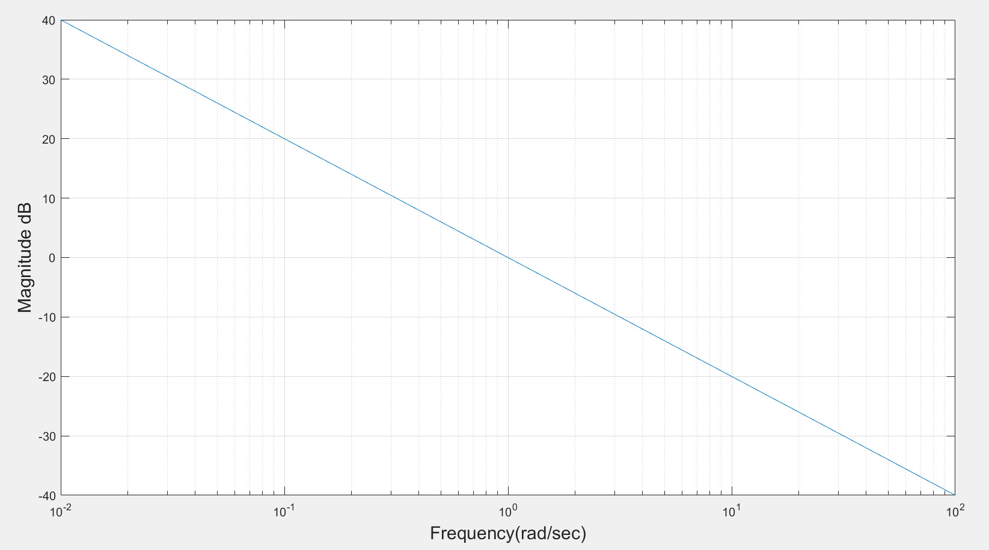

Figure 5: Asymptotic magnitude bode plot for $\frac{1}{s}$

1. For $\frac{1}{Ts+1}$, putting T = 0.4

T(s) = $\frac{1}{0.4s+1}$ now put s=jω

T(jω) = $\frac{1}{0.4jω+1}$--------(a)

Now,

$(jω)$ = $\left(0+1j\right)$ = $\left(\text{cos}\frac{π}{2}+j\text{sin }\frac{π}{2}\right)ω$………. (b)

Putting (b) in (a)

T(jω) = $\frac{1}{0.4(ωcos\frac{π}{2} +jωsin \frac{π}{2}) +1}$ = $\frac{1}{\left(0.4ωcos\frac{π}{2}+1\right)+ j0.4ωsin \frac{π}{2}}$

Magnitude, |T(jω) | =

=

=

Now, Magnitude in dB, |T(jω) | dB = -20log ${\text{(}{0.16ω}^{2}\text{+ }1^{2}\text{+ }0.8ω\text{cos}\frac{π}{2}\text{)}}^{\frac{1}{2}}$

For approximation we consider $1^{2}$ = $0.16ω^{2}|_{ω=ω_{cr}}$.We obtain corner frequency, $ω_{cr}$ = $|\frac{1}{0.4}|$.

Now, following approximation of magnitude is obtained:

1. For ω ≤ , |T(jω) | dB = -20log ${(1^{2})}^{\frac{1}{2}}$ = -20log|1|.
2. For ω >, |T(jω) | dB = -20log ${(0.16.ω^{2α})}^{\frac{1}{2}}$ = -20log (0.4.ω)

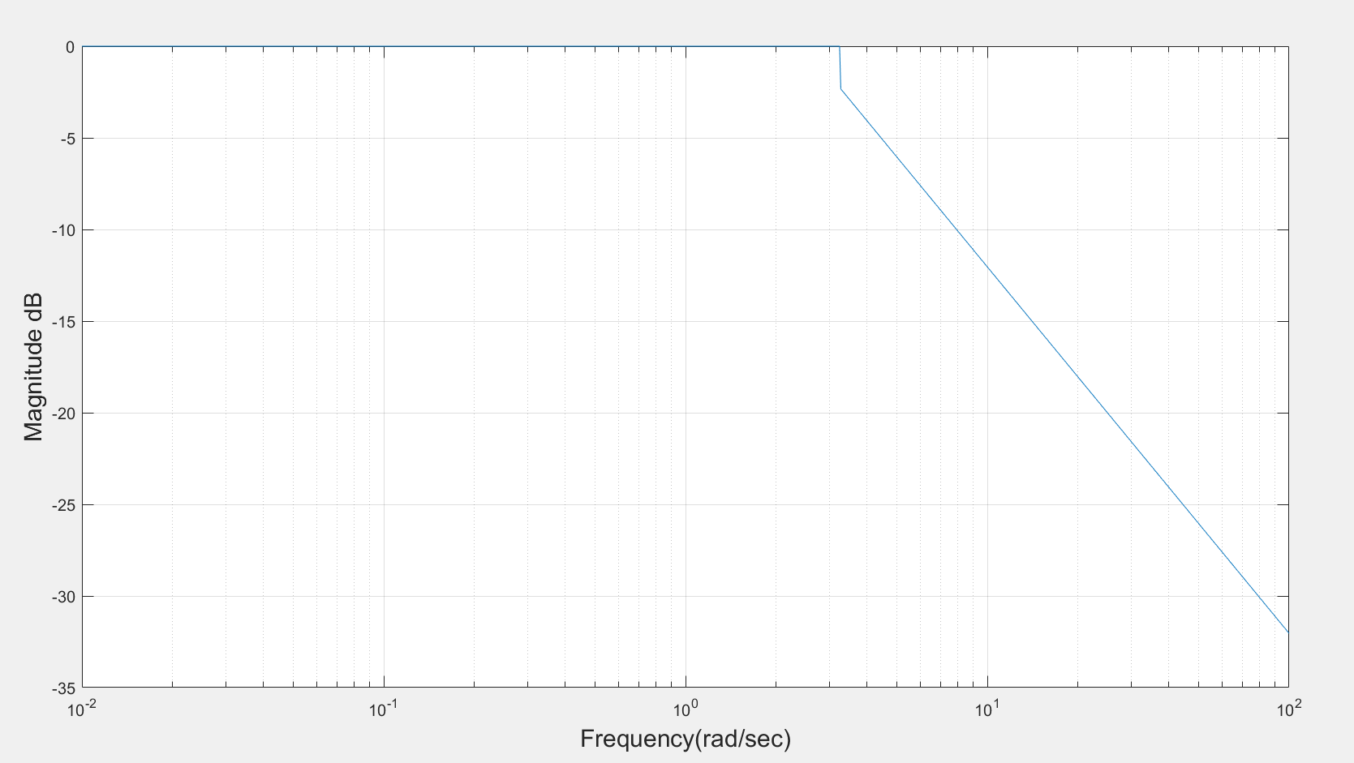

Figure 6: Asymptotic magnitude bode plot for $\frac{1}{(Ts+1)}$

1. L(s) is composed of basic terms, by adding the asymptotic plot of ( $\frac{K}{Ts+1}), ( \frac{1}{s} )$ $\left(K_{p}\right), \left(K_{d}\right) and (s^{β}+\frac{1}{K_{d}})$ one can find asymptotic plot for L(s)

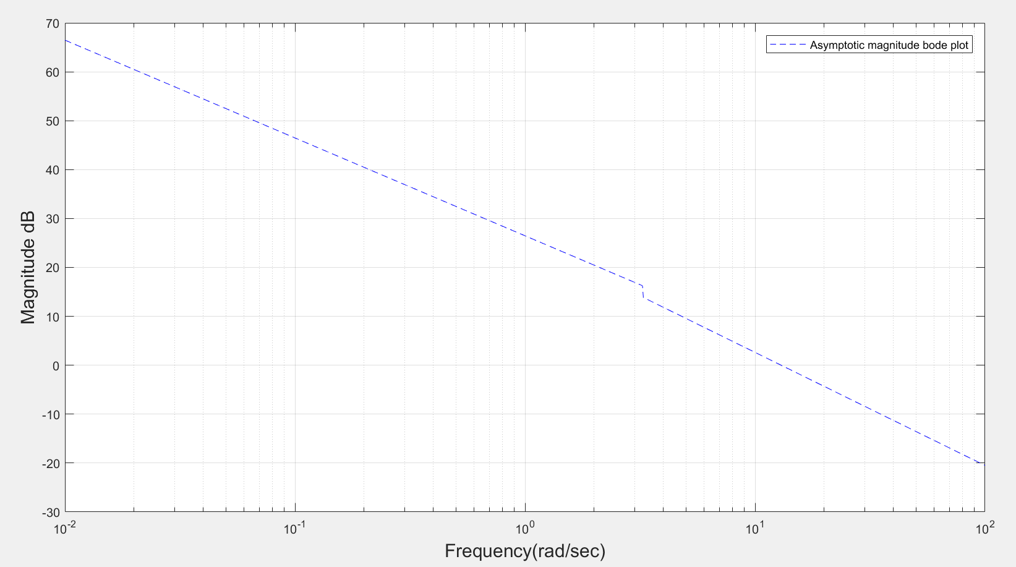Figure 7: Asymptotic magnitude bode plot for L(s)

1. For exact magnitude bode plot of L(s)

L(s) = P(S)C(s)

= ($\frac{K}{Ts+1})( \frac{1}{s} )$ $(K_{p})(K_{d})(s^{β}+\frac{1}{K_{d}})$

Now,

Magnitude, |L(jω)| = 20log ${\{\left(\frac{K}{Tjω+1}\right)\left( \frac{1}{jω} \right)\left(K_{p}\right)\left(K_{d}\right)\left(({jω)}^{β}+\frac{1}{K_{d}}\right)\}}^{\frac{1}{2}}$

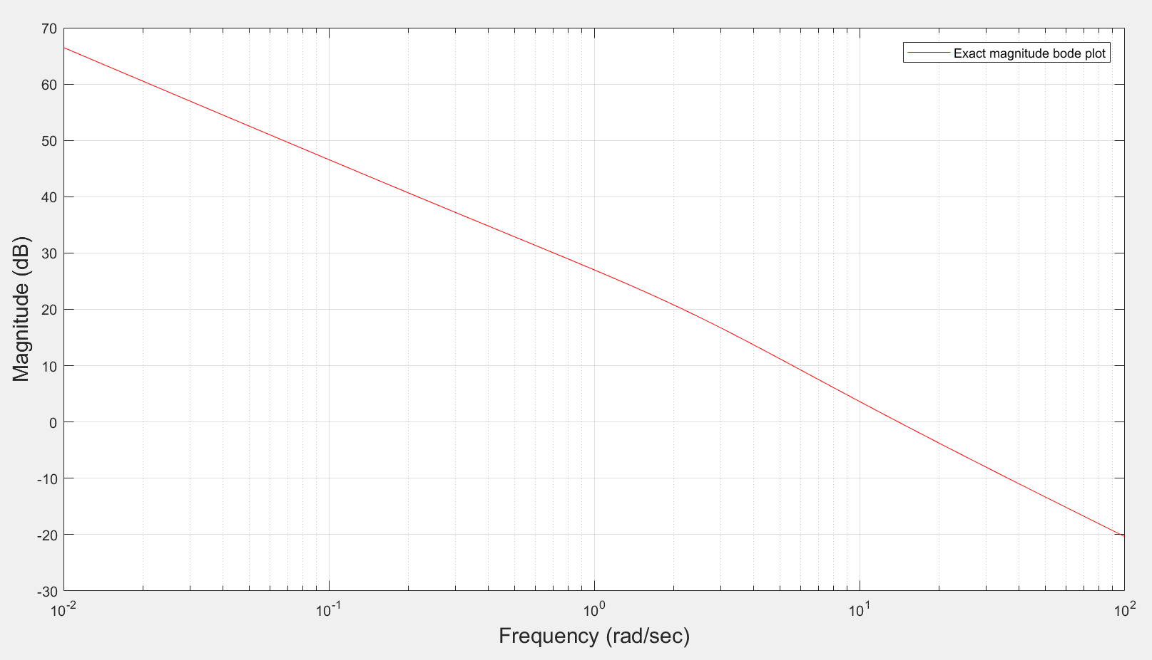

Fig 8: Exact magnitude bode plot for L(s)

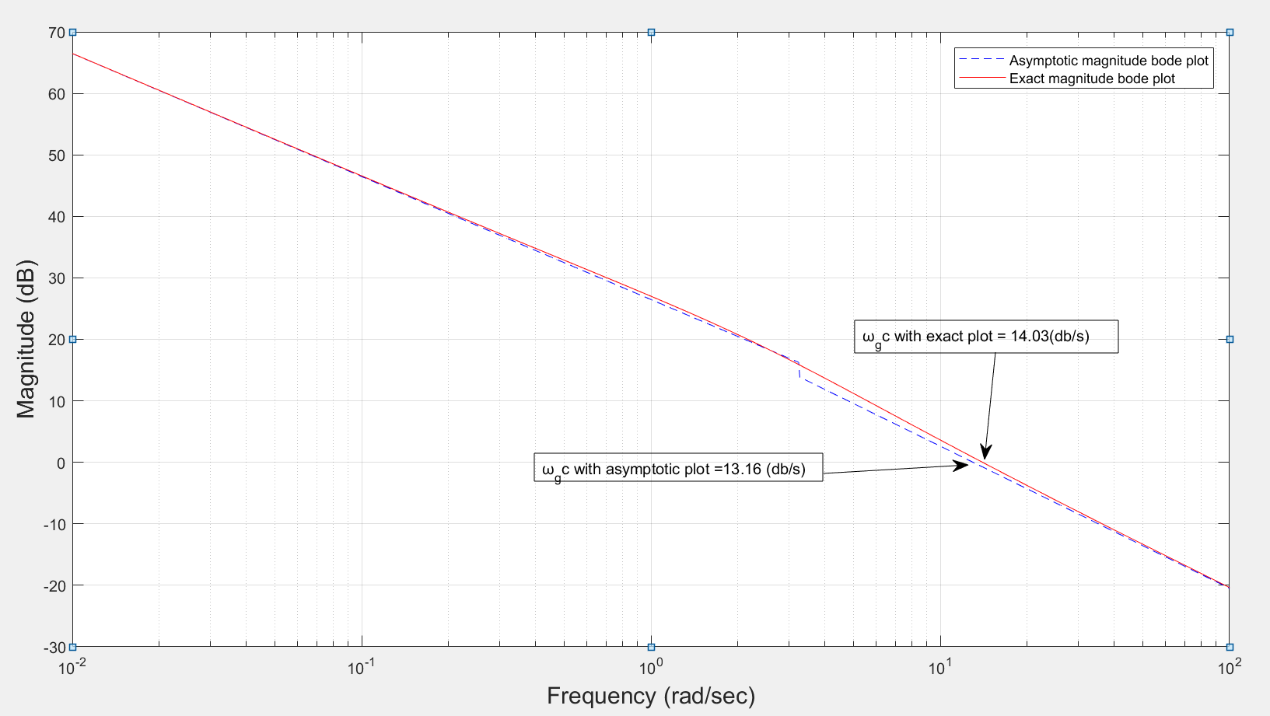

Fig 9: Real and asymptotic magnitude bode plot for L(s)

From fig 9, $ω_{gc}$ is obtained as

1. $ω_{gc}$ for asymptotic = 13.16 (drad/sec)
2. $ω_{gc}$ for exact plot = 14.03(rad/sec)

**Matlab**

clc;

clf;

clear all;

close all;

Kp = 13.86;

Kd = 0.368;

beta = 0.844;

K= 1.52;

T = 0.4;

Wcr = (abs(1/Kd))^(1/beta);

Wcr1 = (abs(1/0.4));

w = logspace(-2 , 2, 1000);

mask = w < Wcr;

mask1 = w < Wcr1;

mag1 = 20*log10(Kp)*ones(size(w));

mag2 = 20*log10(Kd)*ones(size(w));

mag3 = 20*log10(K)*ones(size(w));

mag4 = mask.*(20*log10(1/Kd)) + (~mask).*(20*beta*log10(w));

mag5 = -20*log10(w);

mag6 = (mask1).*(-20*log10(1)) + (~mask1).*(-20*log10(0.4*w));

combined = mag1 + mag2 + mag3 + mag4 + mag5 + mag6 ;

figure(1);

plot(1,1);

semilogx(w, mag1)

xlabel('Frequency(rad/sec)','FontSize', 15);

ylabel('Magnitude dB','FontSize', 15);

grid on;

figure(2);

plot(1,2);

semilogx(w, mag2)

xlabel('Frequency(rad/sec)','FontSize', 15);

ylabel('Magnitude dB','FontSize', 15);

grid on;

figure(3);

plot(1,3);

semilogx(w, mag3)

xlabel('Frequency(rad/sec)','FontSize', 15);

ylabel('Magnitude dB','FontSize', 15);

grid on;

figure (4);

plot(1,4);

semilogx(w, mag4)

xlabel('Frequency(rad/sec)','FontSize', 15);

ylabel('Magnitude dB','FontSize', 15);

grid on;

figure (5);

plot(1,5);

semilogx(w, mag5)

xlabel('Frequency(rad/sec)','FontSize', 15);

ylabel('Magnitude dB','FontSize', 15);

grid on;

figure (6);

plot(1,6);

semilogx(w, mag4)

xlabel('Frequency(rad/sec)','FontSize', 15);

ylabel('Magnitude dB','FontSize', 15);

grid on;

figure(7);

plot(1,7);

semilogx(w, combined,'Color','blue','LineStyle','--')

xlabel('Frequency(rad/sec)','FontSize', 15);

ylabel('Magnitude dB','FontSize', 15);

grid on;

legend('Asymptotic magnitude bode plot','Location','NorthEast')

plot(1,1);

semilogx(w, combined,'Color','blue','LineStyle','--')

xlabel('Frequency(rad/sec)','FontSize', 15);

ylabel('Magnitude dB','FontSize', 15);

grid on;

hold on;

clc;

clear

K = 1.52;

Kp = 13.86;

Kd = 0.368;

beta = 0.844;

T = 0.4;

w=logspace(-2,2,1000);

Mag=@(w) (20*log10(abs(sqrt(Kp).^2)) + 20*log10(abs(sqrt(Kd).^2)) + 20*log10(abs(sqrt(K).^2)) + 20*log10(abs(sqrt((i.*w).^beta + (1/Kd)).^2)) - 20*log10(abs(sqrt((T*(i.*w)) + 1).^2)) - 20*log10(abs(sqrt(i*w).^2)));

semilogx(w,Mag(w) ,'Color','red');

hold on;

grid on;

xlabel('Frequency (rad/sec)','FontSize', 15);

ylabel('Magnitude (dB)','FontSize', 15);

legend('Asymptotic magnitude bode plot','Exact magnitude bode plot','Location','NorthEast')